Domain and Hosting steps:

A. Domain steps:

1- Find a GoDaddy website to buy a domain. Then click on the link to enter the site.

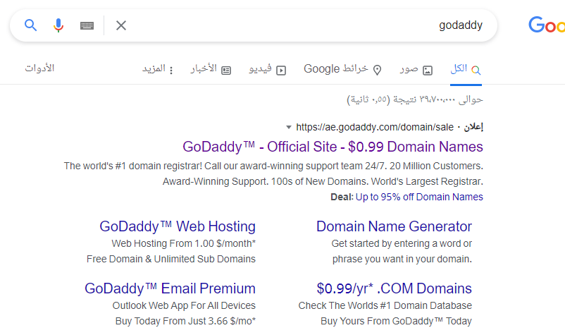

2-The home page of the site appears when text box (Find your perfect domain) write the name of the domain you want to buy then press Enter.

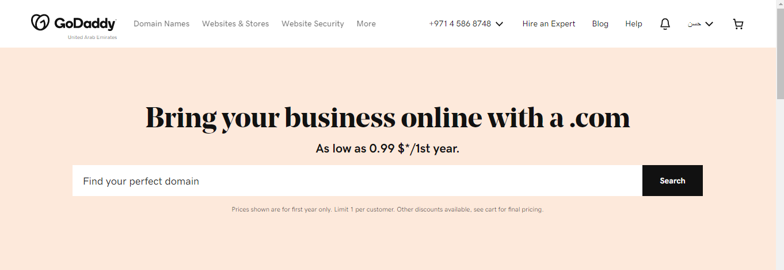

3-Then, the name of the available domains that can be purchased will appear to you, and then click on Add to Card.

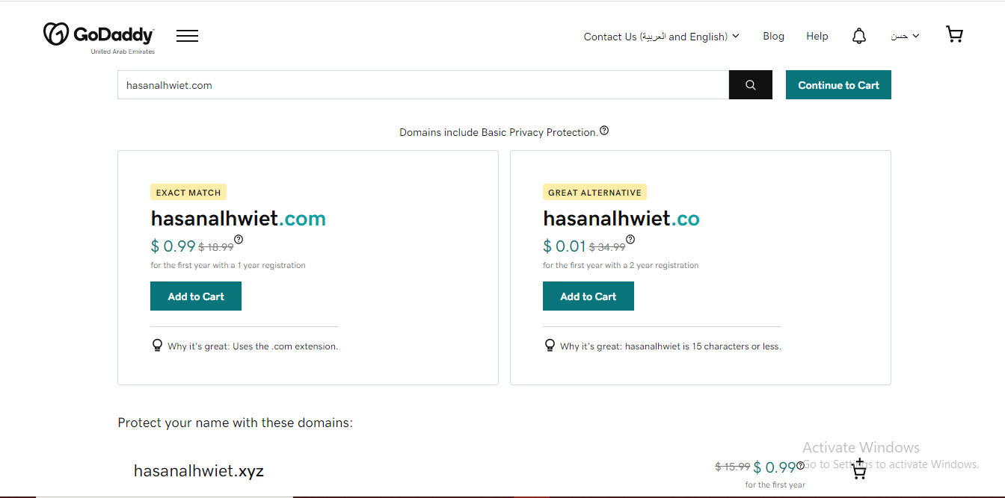

4-Next, next to the page, you will see the domain name and its price, click (Looks Good, Keep Going).

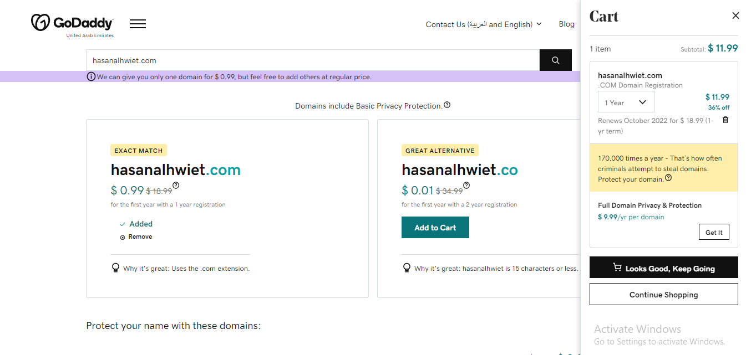

5-After that, the total price for the domain name and any additions you want appears, then after completing that, click on (I'm Ready to Pay)

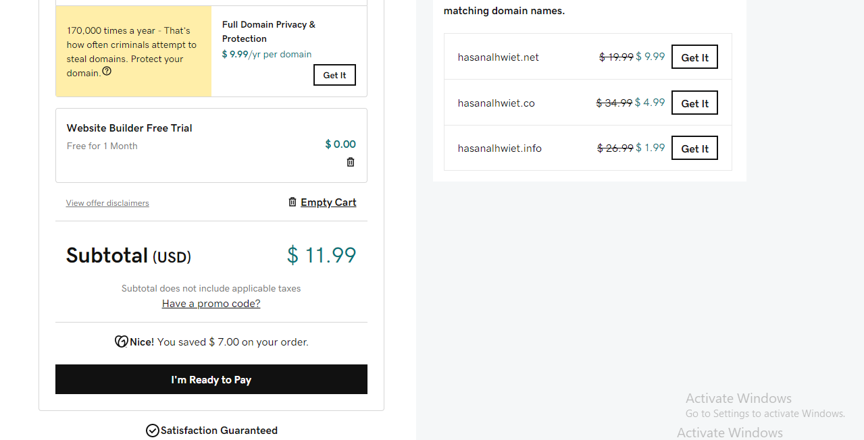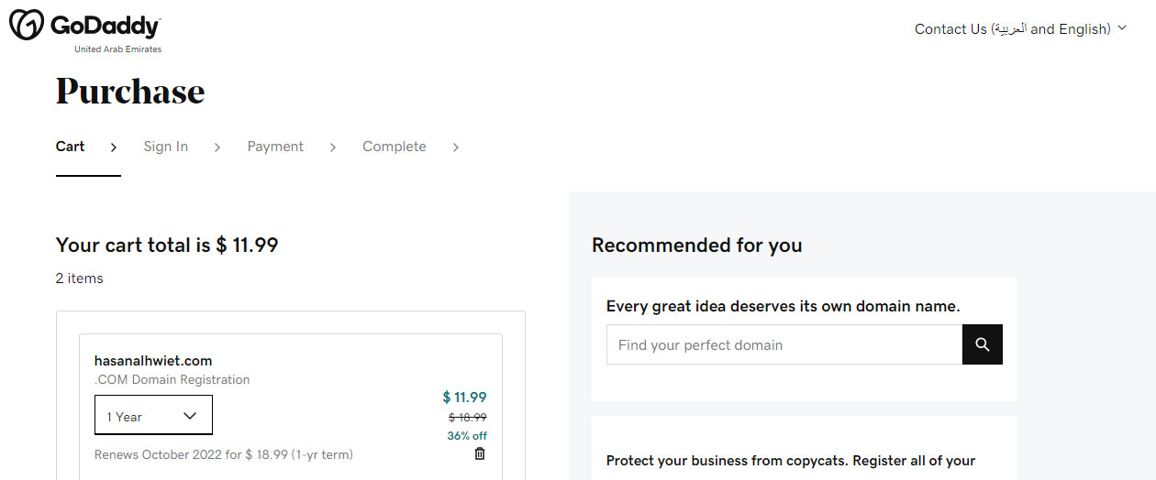

6-Fill in the required data in order to purchase a domain name.

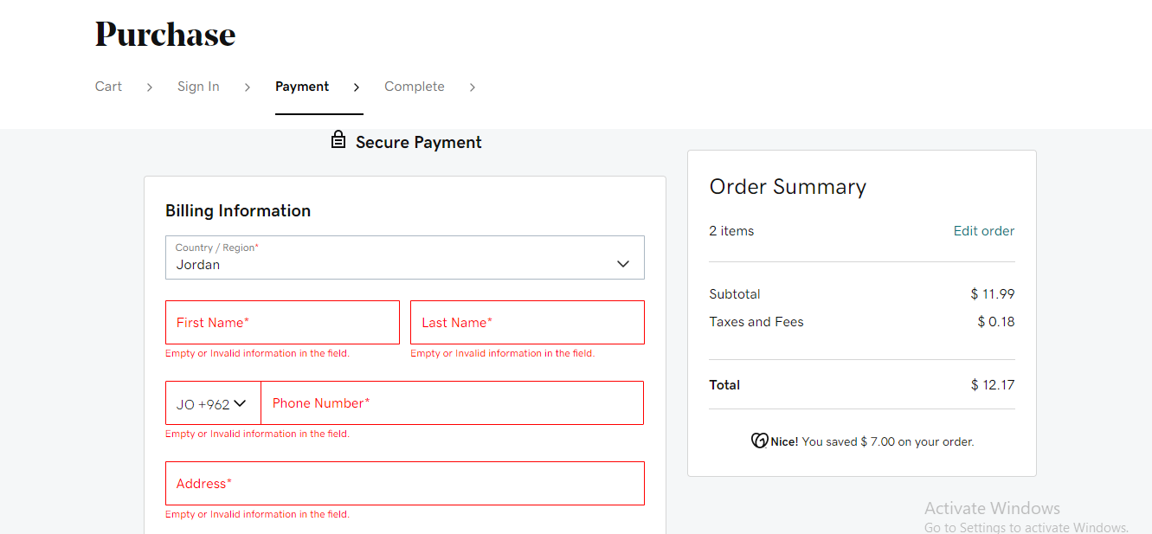

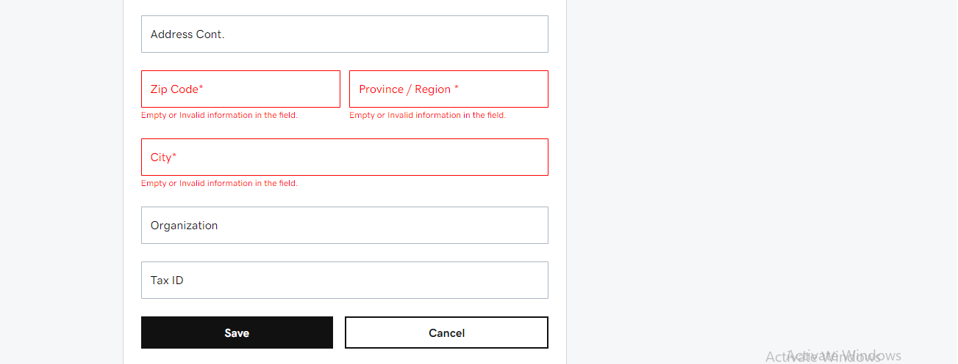

7-Enter the card information to purchase the domain name then click on (Complete Purchase).

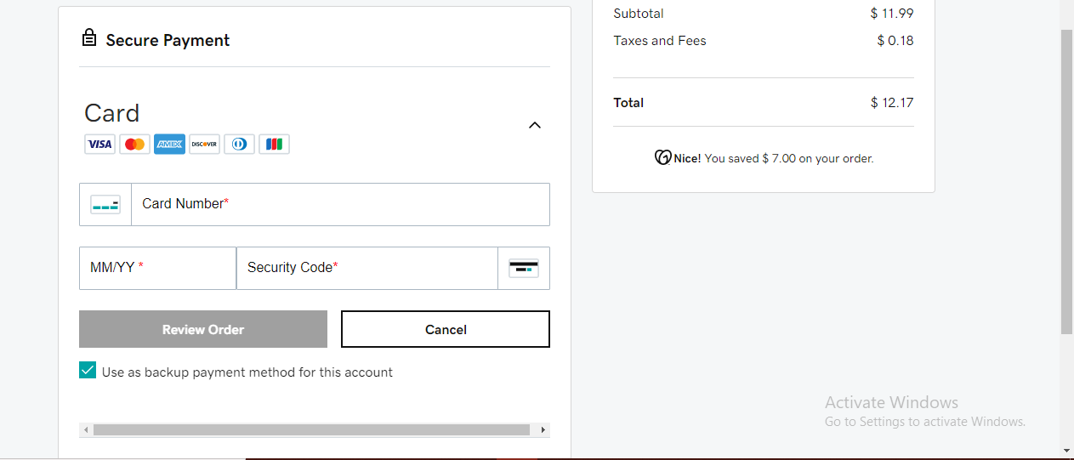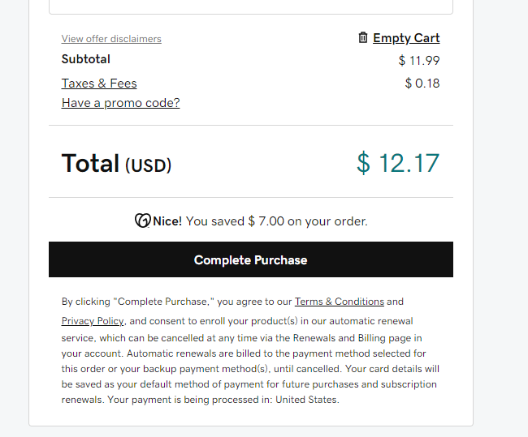

B. Hosting steps:

1- Find a Free Hosting website to buy hosting. Then click on the link to enter the site.

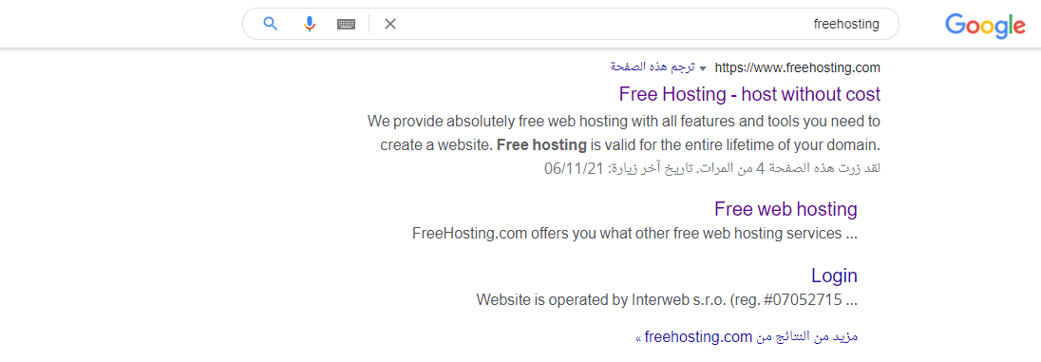

2-The homepage of the site appears Scroll down.

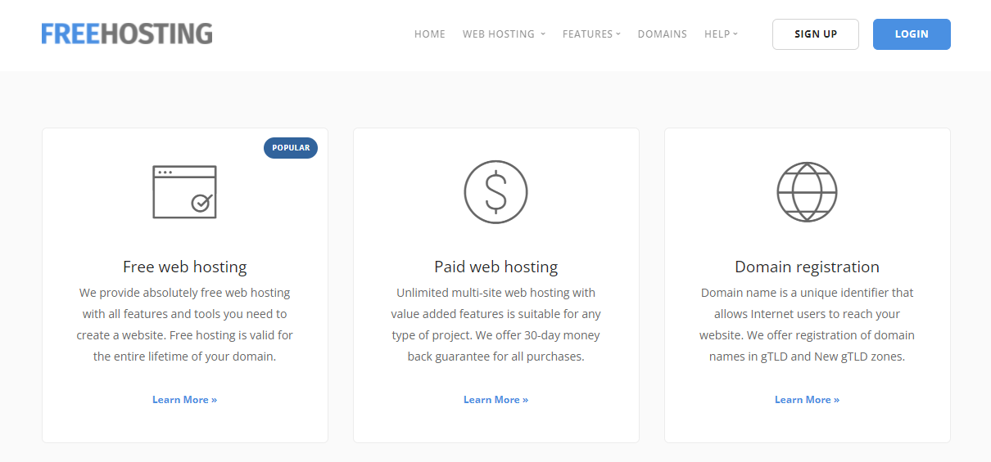

3-Stand here and click on a free hosting package

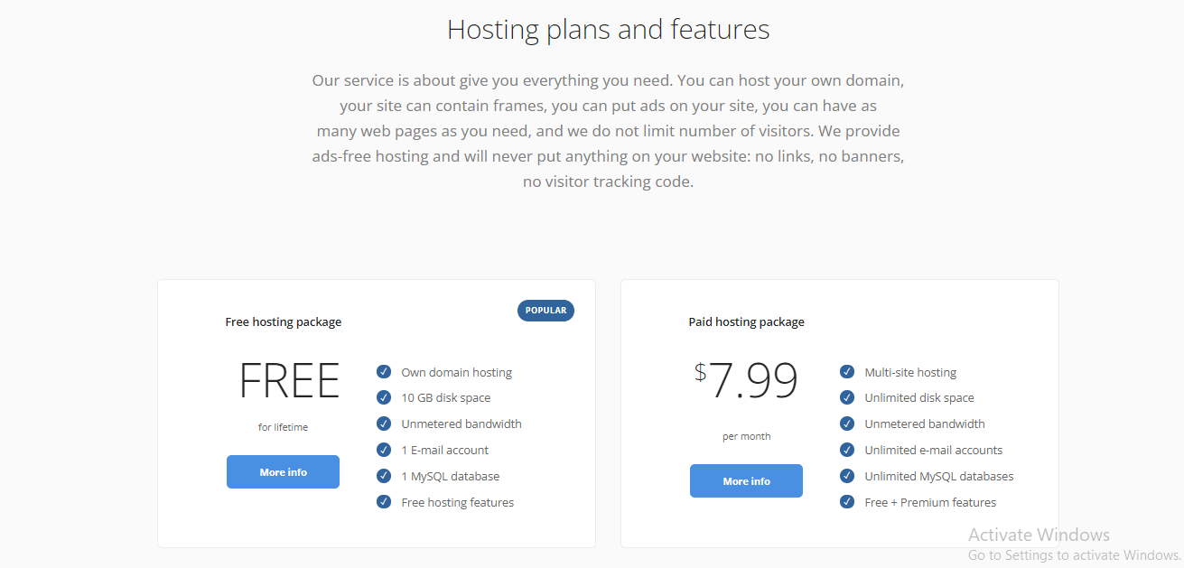

4-When this page appears, click (sign up for free).

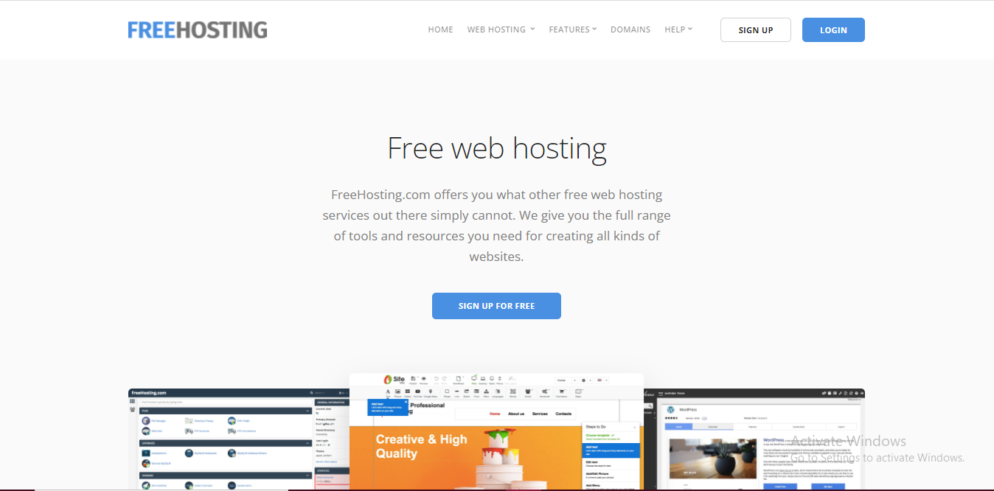

5- Fill in the required data in order to purchase a domain name.

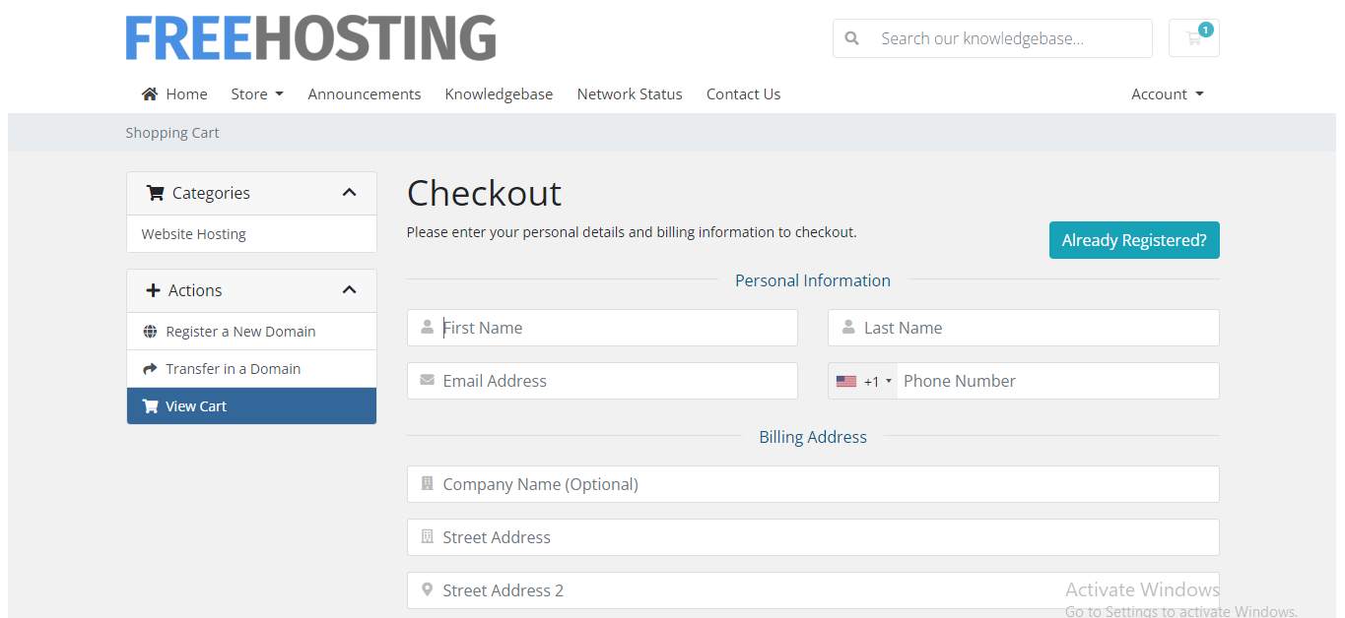

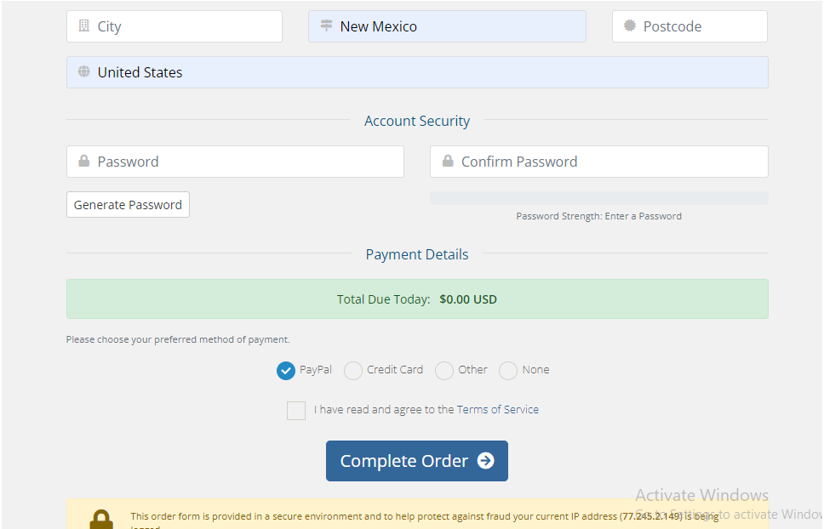

6-After creating an account, it will send you to this page, choose the third option, type your domain name, and click Use

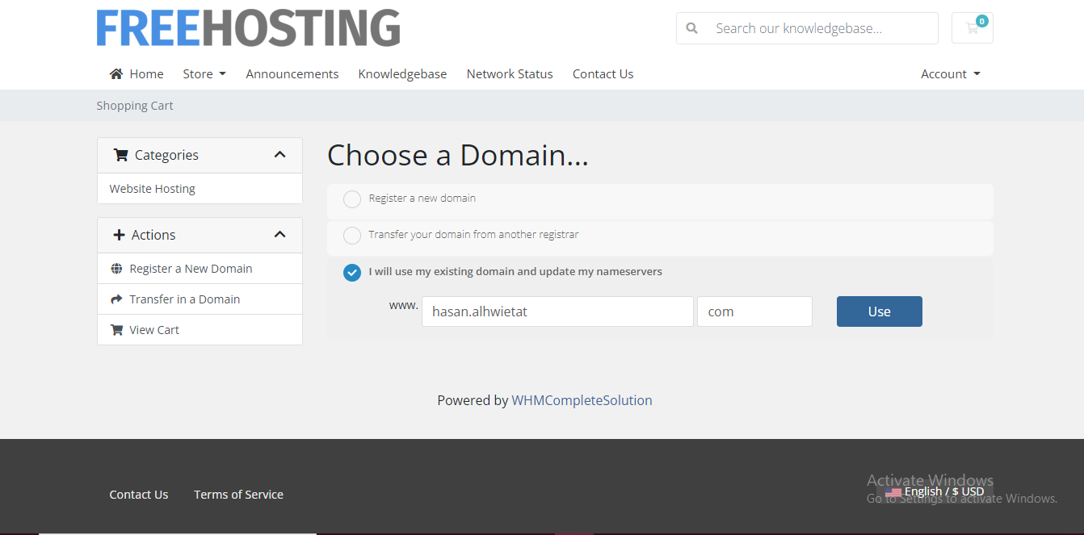

7-When this page appears showing information about the host you want to buy, click Continue.

8-When this page appears to confirm your purchase, click Continue.9- Hosting has been created for your domain.

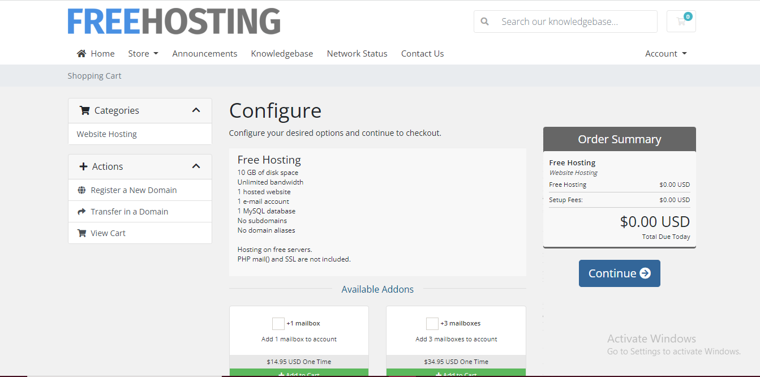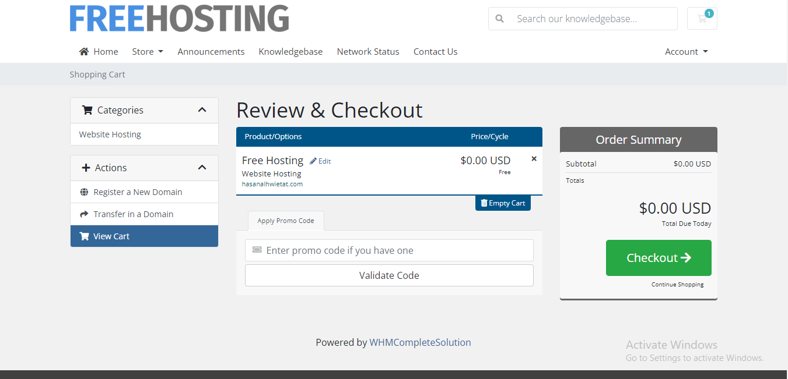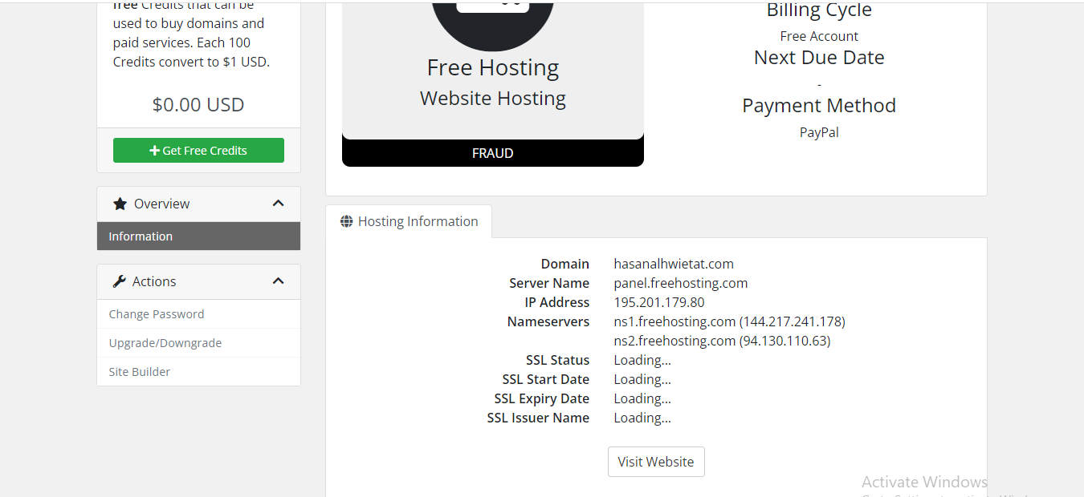

C. Steps to associate a domain with hosting:

1- Make a copy of the name server and put it in the domain location.

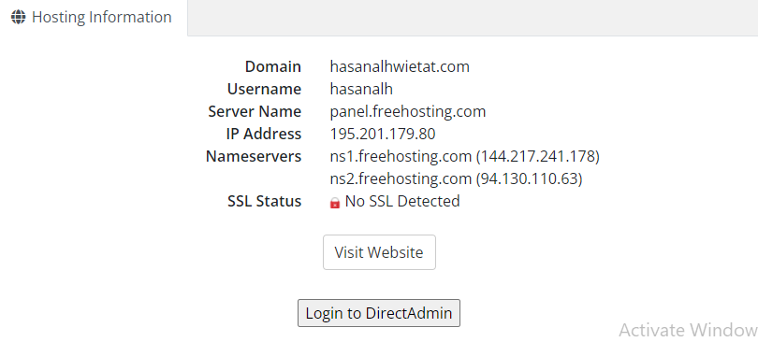

2- Go to the domain's website and go to DNS Management, then scroll down.

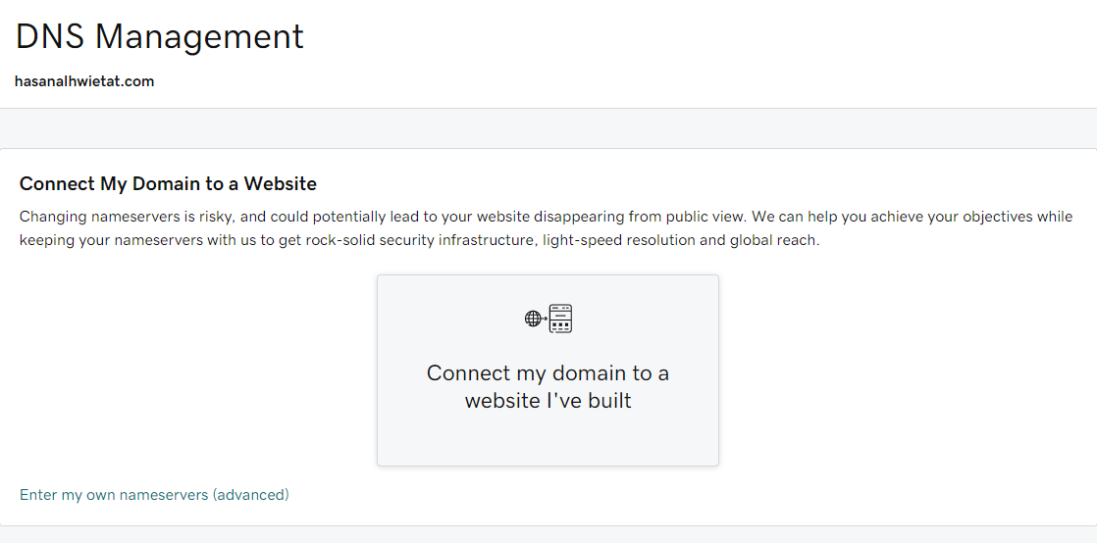

3- Then stop here and click Change.

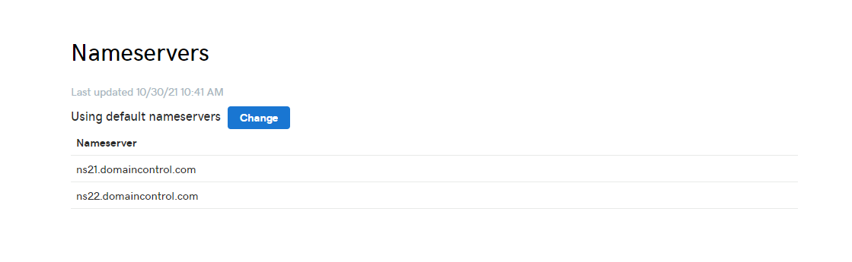

4- Put the name servers that you copied from the hosting site and put them here, then click Save.

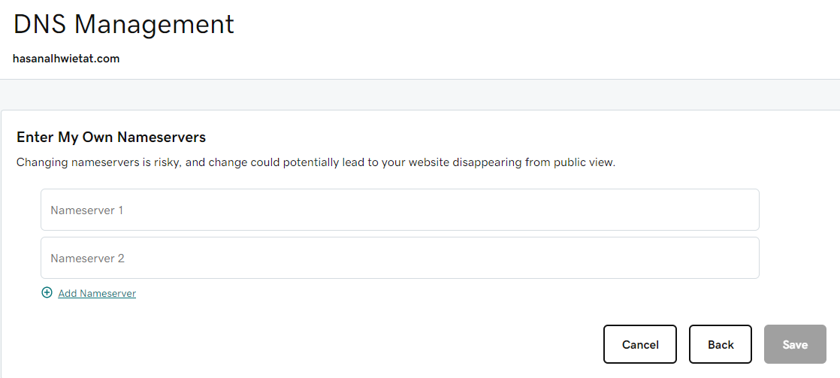

5- After changing the name servers, click Yes and then click Continue.

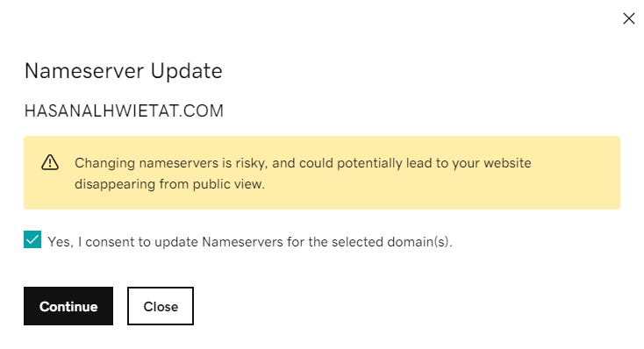

6- The name servers have been changed successfully.

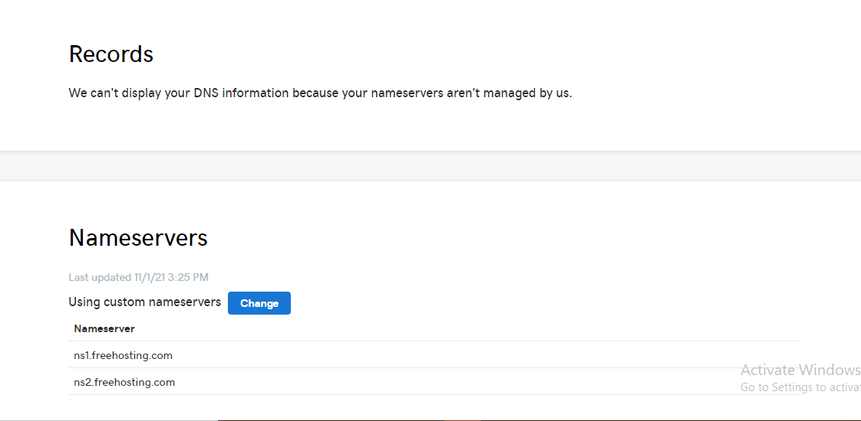

7- When you search for your domain name on Google, this page will appear. You have a website and hosting as well. You have to build this page.

